PROJECT REPORT

TechStore: An E-Commerce Platform

Semester:
CS – 5th Sem “B”

Submitted by
Muhammad Saif Ud Din 23014119-124
Ali Sheraz 23014119-180

Submitted to
Sir Atif Shehzad

Department of Computer Science

University of Gujrat



Introduction & Problem Statement:

1. Abstract
TechStore is a full-stack web application designed to provide a seamless online shopping experience for electronics. Built using the MERN stack (MongoDB, Express.js, React.js, Node.js), the application allows users to browse products, filter by categories (such as Mobiles, Laptops, and Gaming), add items to a cart, and complete purchase orders. The system ensures security through JWT authentication and password hashing.

2. Problem Statement
In the rapidly evolving digital market, traditional brick-and-mortar stores often lack the convenience of instant product comparison and 24/7 availability. Furthermore, many existing e-commerce templates are either too complex for small vendors or lack essential reactive features that modern users expect.

The specific problems addressed by TechStore are:

User Experience: Providing a responsive, single-page application (SPA) experience where pages load instantly without refreshing.

Product Discovery: Users often struggle to find specific electronics; TechStore solves this with dedicated category sections (Mobiles, Gaming, Audio) and a "Best Collection" feature.

Data Integrity: Managing product stock and user orders efficiently using a NoSQL database structure.

3. Project Scope
The scope of TechStore includes:

User Module: Registration, Login (Secure), and Profile Management.

Product Module: Viewing product details, filtering by category, and stock management.

Order Module: Cart management, shipping address collection, and order generation.

Responsive Design: Optimized for desktop and mobile viewing.

Technology Stack

To achieve the project objectives, the following technologies were used:

1. Frontend (Client-Side)
React.js: Used for building the user interface based on functional components.

React Hooks: Utilized useState, useEffect, useNavigate, and useLocation for state management and side effects.

React Router Dom: For handling navigation between different screens (Home, Product, Cart, Login) without page reloads.

CSS3: Custom styling (App.css) ensuring a unique "TechStore" brand identity using a dark blue and cream color palette.

2. Backend (Server-Side)
Node.js: The runtime environment for executing JavaScript on the server.

Express.js: A framework used to build RESTful APIs to handle HTTP requests (GET, POST) for products and users.

Bcryptjs: Used for hashing user passwords before saving them to the database to ensure security.

JSON Web Token (JWT): Used for secure user authentication and session management.

3. Database
MongoDB: A NoSQL database used to store application data in JSON-like documents.

Mongoose: An Object Data Modeling (ODM) library used to manage relationships between data and enforce schema validation.

Database Schema Diagram

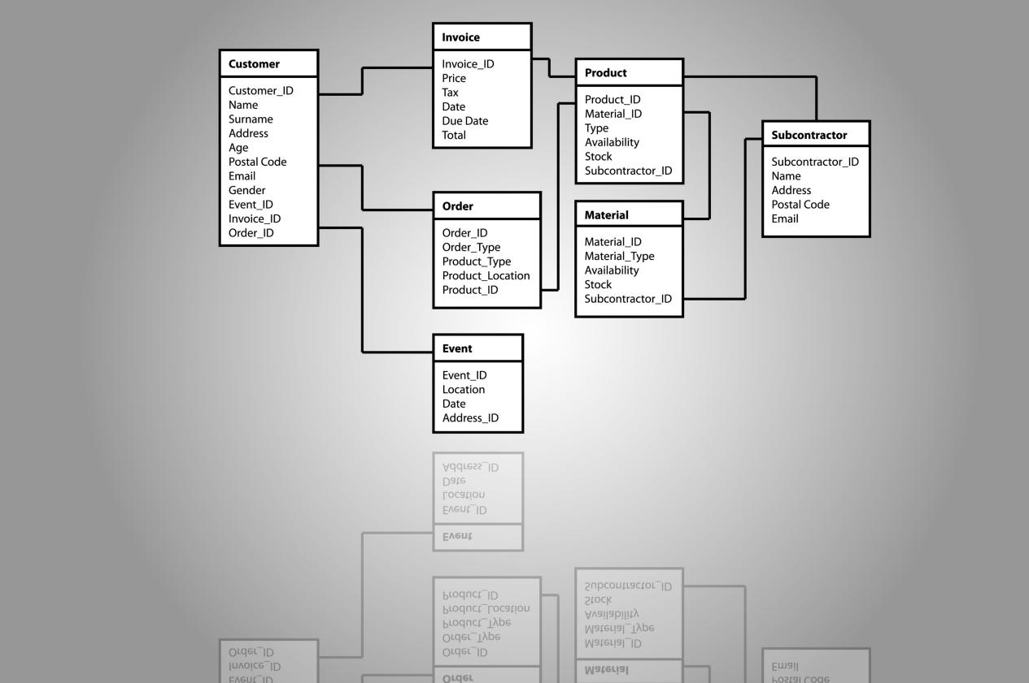

Schema Description:

Users Collection: Stores user credentials and admin status.

Products Collection: Stores item details, price, stock, and category.

Orders Collection: Links a User to multiple Products, storing the shipping address and total price.

Implementation Details

1. Authentication Flow
Security is handled using JSON Web Tokens (JWT). When a user registers, their password is encrypted using bcrypt. Upon login, the backend verifies the hash and issues a token. This token is stored in the browser's Local Storage to keep the user logged in across sessions.

2. State Management
The application uses React's useState and useEffect hooks heavily.

Product Loading: Data is fetched from the backend API via Axios inside a useEffect hook.

Cart Management: The cart state is synchronized with Local Storage. When a user refreshes the page, the useState initialization logic checks Local Storage to restore the cart items.

3. Navigation & Scrolling
A custom ScrollToTop component and logic within the Header ensure that users are always taken to the correct section of the page. If a user clicks "Products" from a different page, the app intelligently navigates to the Home screen first and then smooth-scrolls to the product section.

Conclusion

The TechStore project successfully demonstrates the capability of the MERN stack in building robust e-commerce applications. The project fulfills the requirements of authentication, CRUD operations, database relationships, and responsive frontend design.

By implementing custom category logic, "Add to Cart" functionality without Redux, and smooth scrolling navigation, the application provides a user-friendly experience that mimics real-world standards.

Git-Hub Repository Link

Link : https://github.com/MSaifUdDin-999/AWD-Project-TechStore.git

References

- React Documentation: https://reactjs.org/

- MongoDB Documentation: https://docs.mongodb.com/

- Node.js API: https://nodejs.org/

- Express.js Routing: https://expressjs.com/

